**COSC344 Assignment 2**

Group: 3

Group Leader: Elsie Sun

Members: Andy Randell, Ben Taylor, Elsie Sun, Nikki Meadows

**1. Revised ER Diagram**

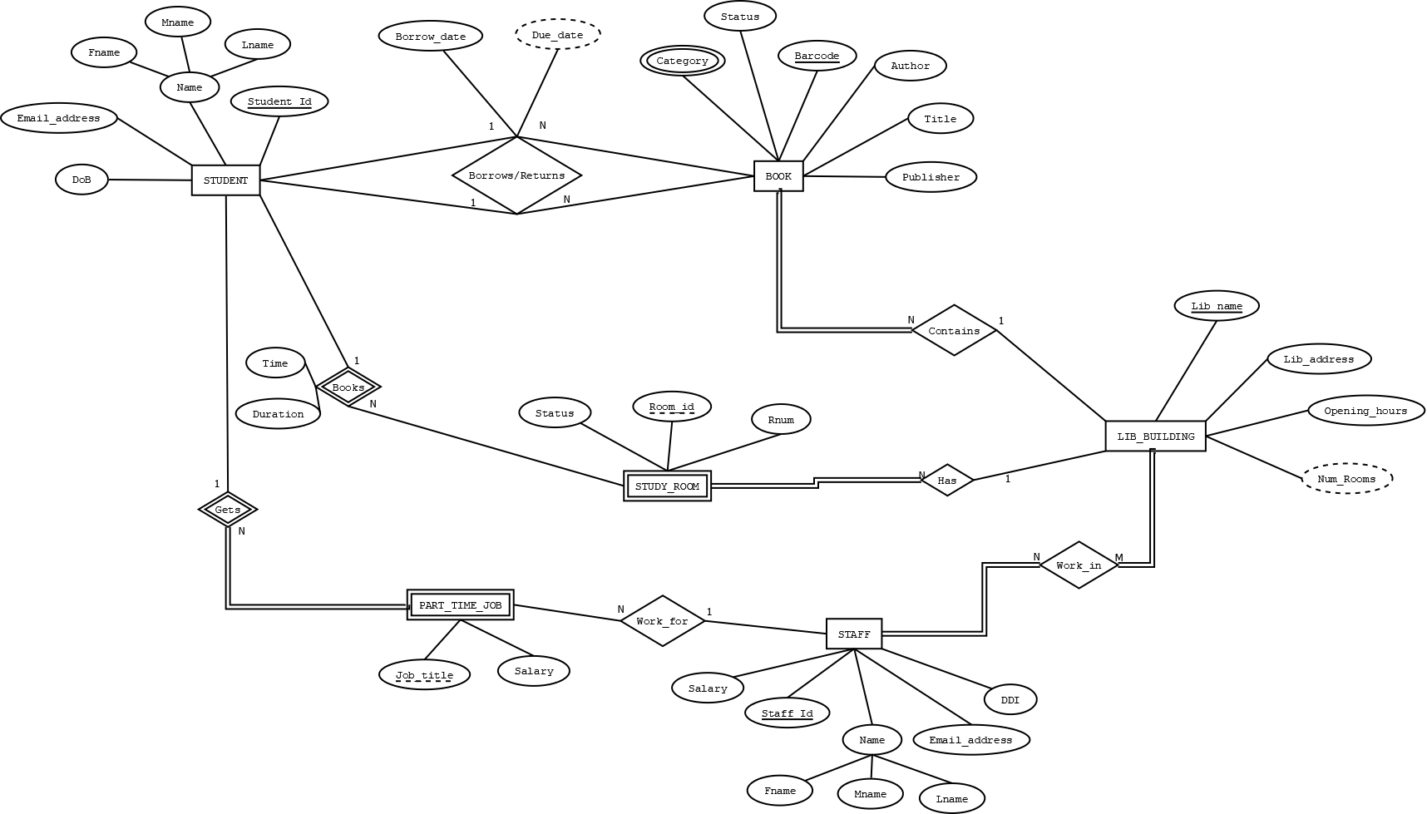

**1.a) Changes from previous ER diagram:**

**Changes to attributes:**

* The first change that was made from the previous ER diagram was to change DoB under the student entity from a derived attribute to an attribute. As we will store the exact DoB of a student, there is no need to derive this attribute.
* Another attribute that has changed is the Due_date in the Borrows/Returns relationship between the Student and Book entities. Due_date is now a derived attribute, as this can be calculated from the Borrow_date attribute.
* The Return_date attribute has been removed from the Borrows/Returns relationship in order to remove duplication as we are already storing the Due_date for this relationship.
* Under the BOOK entity, the IBSN attribute has been removed and replaced with Barcode. IBSN has been removed from the diagram as this number is unable to be used as a key attribute as multiple copies of the same book are able use the same IBSN. As a Barcode is most often used in libraries to identify individual books, this is now the key attribute in the BOOKS entity.
* Under the BOOK entity, the Book_status attribute has been changed to a single valued attribute named Status.
* Under the STUDY_ROOM entity, the Room_status attribute has also been changed to a single valued attribute named Status.
* The Department attribute has been removed from the PART_TIME_JOB entity as for simplicity purposes each employed student would work in the same department.
* Under the BOOK entity, the Location attribute has been removed as the location of a book is represented by the CONTAINS relationship between BOOKS and LIB_BUILDING.
* The Lib_name attribute has been removed from the STUDY_ROOM entity as this is represented by the HAS relationship between the STUDY_ROOM and LIB_BUILDING entities.
* The final attribute that has been modified in the revised diagram is Num_rooms under the LIB_BUILDING entity is now represented as a derived attribute for each library.

**Changes to entities:**

* The STUDY_ROOM entity has been modelled in the revised ER diagram as a weak entity type due to the fact that rooms in each different library are able to have the same Room_id. Room_id has therefore been updated to a weak key attribute to reflect this change.

**Changes to relationships:**

* The name of the relationship between the STUDY_ROOM and LIB_BUILDING entities has been changed from Contains to Has, to ensure that we do not have two relationships with the same name in our diagram.
* The two relationships from the previous diagram between the STUDENT and BOOK entities have been combined into one Borrows/Returns relationship.

**2. Relational Schema**

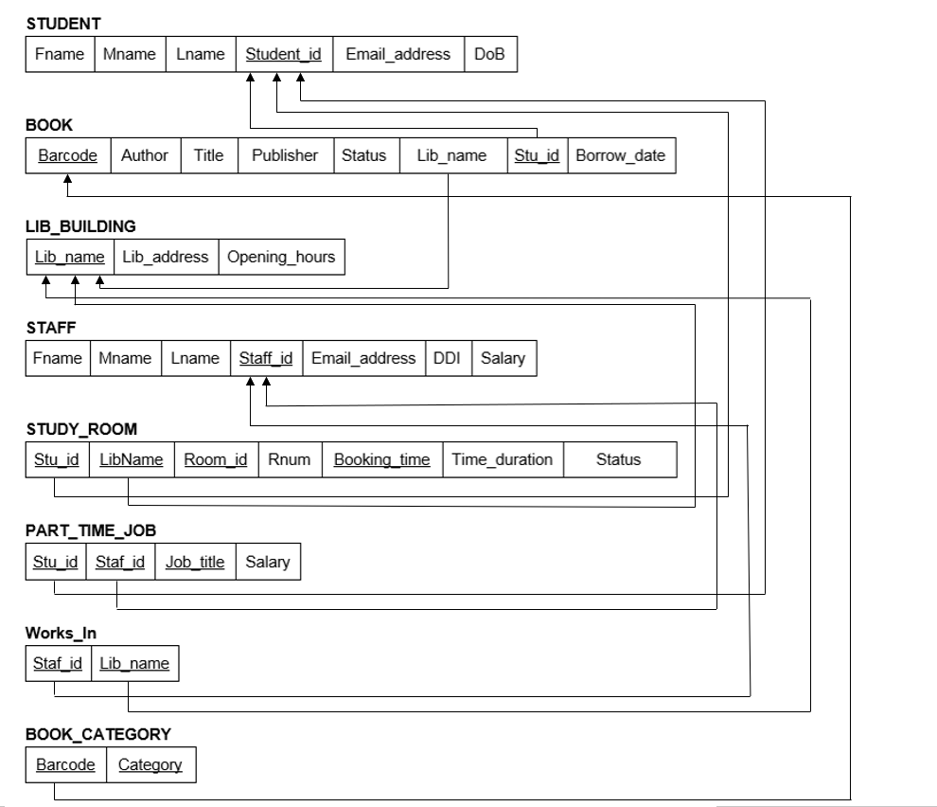

**3. Normalization**

**Step 1: 1NF**

All relations are in 1NF. In the above relationship model,the multivalued attribute ‘CATEGORY’ in ‘BOOK’ and the composite attributes ‘Name’ in entities ‘STUDENT’ and ‘STAFF’ are removed, and new relations have been created. So, each domain of each attribute has atomic values only, and each value of each attribute in a tuple has a single value from the domain of the attribute.

**Step 2: 2NF**

BOOK is not in 2NF, because the ‘Title’, ‘Author’, ‘Publisher’, and ‘Lib_name’ depend on ‘Barcode’, and the ‘Borrow_date’ is dependent on ‘Stu_id’ and ‘Barcode’. To get it into 2NF we divide it into the following relations:

BOOK( Barcode, Title, Author, Publisher, Lib_name, Stu_id, Borrow_date, Status)

→ BookInfo(Barcode, Title, Author, Publisher, Status, Lib_name)

→ StudentBook(Stu_id, Barcode, Borrow_date)

**Step 3: 3NF**

3NF has no non-prime attribute that is transitively dependent on the primary key. PART_TIME_JOB and STUDY_ROOM are not in 3NF, because when ‘Job_title’ has changed, ‘Salary’ should be changed as well in ‘PART_TIME_JOB’. Also, when ‘Room_id ’has changed, ‘Lib_name’ should be changed as well in ‘STUDY_ROOM’. In addition, in ‘STUDY_ROOM’, choosing ‘Booking_time’ as a primary key, because ‘Stu_id’, ’room_id’ and ‘Booking_time’ are highly correlated, and using ‘Booking_time’ to distinguish multiple bookings come from one student. To get it into 3NF we divide them into the following relations:

PART_TIME_JOB(Stu_id, Sta_id, Job_title, Salary)

→ StudentJob(Stu_id, Staf_id, Job_title)

→ JobInfo(Job_title, Salary)

STUDY_ROOM(Stu_id, Lib_name, Room_id, Booking_time, Rnum, Time_duration, Status)

→ StudentRoom(Stu_id, Room_id, Booking_time, Time_duration)

→ RoomInfo(Room_id, Rnum, Lib_name, Status)

**Step 4: BCNF**

All relations are in BCNF.

**4. Load.sql**

DROP TABLE book_category;

DROP TABLE student_book;

DROP TABLE student_room;

DROP TABLE room_info;

DROP TABLE works_in;

DROP TABLE student_job;

DROP TABLE staff;

DROP TABLE bookinfo;

DROP TABLE job_info;

DROP TABLE student;

DROP TABLE lib_building;

CREATE TABLE student(

fname VARCHAR2(15) NOT NULL,

mname CHAR,

lname VARCHAR2(15) NOT NULL,

student_id CHAR(10) PRIMARY KEY,

email_address VARCHAR2 (28),

dob DATE

);

INSERT INTO student VALUES

('Timothea','J','Warner','1234567','warti100@student.otago.ac.nz',TO_DATE('01-05-1997', 'DD-MM-YYYY'));

INSERT INTO student VALUES

('Gina','A','Alvarez','7895623','alvgi101@student.otago.ac.nz',TO_DATE('21-12-1998','DD-MM-YYYY'));

INSERT INTO student VALUES

('Theo','T','Stevens','4562359','steth102@student.otago.ac.nz',TO_DATE('15-01-1997','DD-MM-YYYY'));

INSERT INTO student VALUES

('Estelle','A','Garner','4513150','gares103@student.otago.ac.nz',TO_DATE('22-12-2000','DD-MM-YYYY'));

INSERT INTO student VALUES

('Ramona','R','Sims','5147967','simra104@student.otago.ac.nz',TO_DATE('31-12-2002','DD-MM-YYYY'));

INSERT INTO student VALUES

('Eugenia','E','Townsend','7894520','toweu105@student.otago.ac.nz',TO_DATE('06-11-1995','DD-MM-YYYY'));

INSERT INTO student VALUES

('Sally','S','Hum','4468206','humsa106@student.otago.ac.nz',TO_DATE('28-11-1998','DD-MM-YYYY'));

INSERT INTO student VALUES

('Alicia','J','Smith','8888222','smial107@student.otago.ac.nz',TO_DATE('30-03-1999','DD-MM-YYYY'));

INSERT INTO student VALUES

('Jennifer','X','Wallace','9658201','walje108@student.otago.ac.nz',TO_DATE('20-02-2002','DD-MM-YYYY'));

INSERT INTO student VALUES

('Vicky','v','He','8546073','hevic109@student.otago.ac.nz',TO_DATE('11-11-2000','DD-MM-YYYY'));

CREATE TABLE lib_building(

lib_name VARCHAR2(20) PRIMARY KEY,

lib_address VARCHAR2(50),

opening_hours VARCHAR2(30)

);

INSERT INTO lib_building VALUES('Central', '65 Albany Street', '7am-11pm');

INSERT INTO lib_building VALUES('Robertson', '135 Union Street East', '7am-11pm');

INSERT INTO lib_building VALUES('Science', '100 Castle Street North', '7am-11pm');

INSERT INTO lib_building VALUES('Law', '85 Albany Street', '7am-11pm');

CREATE TABLE bookinfo(

barcode CHAR(12) PRIMARY KEY,

title VARCHAR2(50) NOT NULL,

author VARCHAR2(30) NOT NULL,

publisher VARCHAR2(30) NOT NULL,

status VARCHAR2(15) NOT NULL,

lib_name VARCHAR2(20) NOT NULL CONSTRAINT libbuilding_fk REFERENCES lib_building(lib_name) DISABLE

);

ALTER TABLE bookinfo ENABLE CONSTRAINT libbuilding_fk;

INSERT INTO bookinfo VALUES('278462740182', 'To Kill a Mockingbird', 'Harper Lee', 'J. B. Lippincott and Co.', 'Unavailable', 'Central');

INSERT INTO bookinfo VALUES('123649071295', 'War and Peace', 'Leo Tolstoy', 'The Russian Messenger.','Unavailable', 'Robertson');

INSERT INTO bookinfo VALUES('874021833362', 'The Handmaid’s Tale', 'Margaret Atwood', 'McClelland and Stewart','Unavailable', 'Law');

INSERT INTO bookinfo VALUES('938566720192', 'The Hobbit', 'J.R.R Tolkien', 'Allen and Unwin', 'Unavailable','Science');

INSERT INTO bookinfo VALUES('876543645110', '1984', 'George Orwell', 'Secker and Warburg', 'Unavailable','Central');

INSERT INTO bookinfo VALUES('198567651657', 'Pride and Prejudice', 'Jane Austen','T.Egertin, Whitehall', 'Available', 'Central');

CREATE TABLE staff(

fname VARCHAR2(15) NOT NULL,

mname CHAR,

lname VARCHAR2(15) NOT NULL,

staff_id CHAR(8) PRIMARY KEY,

email_address VARCHAR2(28),

ddi VARCHAR2(11),

salary NUMBER(6)

);

INSERT INTO staff VALUES

('Pearl','A','Robbins','12345678','robpe12a@otago.ac.nz','+6434798910',30000);

INSERT INTO staff VALUES

('Harmony','B','Cook','12345679','cooha52p@otago.ac.nz','+6434798910',35000);

INSERT INTO staff VALUES

('Tamara','C','Marsh','12496583','marta14s@otago.ac.nz','+6434798914',50000);

INSERT INTO staff VALUES

('Juliet','D','Mills','45612134','milju95o@otago.ac.nz','+6434795116',56320);

INSERT INTO staff VALUES

('Faye','E','Harper','88888884','harfa89q@otago.ac.nz','+6434798803',40000);

CREATE TABLE job_info (

job_title VARCHAR(20) PRIMARY KEY,

salary NUMBER(6) NOT NULL

);

INSERT INTO job_info VALUES

('returns', 3200);

INSERT INTO job_info VALUES

('data entry', 3100);

INSERT INTO job_info VALUES

('help desk', 4000);

CREATE TABLE student_job (

student_id CHAR(10) NOT NULL

CONSTRAINT stu_id_cnst REFERENCES student(student_id) DISABLE,

staff_id CHAR(8) PRIMARY KEY,

job_title VARCHAR(20) NOT NULL

CONSTRAINT job_title_cnst REFERENCES job_info(job_title) DISABLE

);

ALTER TABLE student_job ENABLE CONSTRAINT stu_id_cnst;

ALTER TABLE student_job ENABLE CONSTRAINT job_title_cnst;

INSERT INTO student_job VALUES

('1234567', '12345678', 'returns');

INSERT INTO student_job VALUES

('7895623', '12345679', 'data entry');

INSERT INTO student_job VALUES

('4562359', '12496583', 'returns');

INSERT INTO student_job VALUES

('8888222', '45612134', 'help desk');

CREATE TABLE works_in (

staff_id CHAR(8) NOT NULL

CONSTRAINT staff_id_cnst REFERENCES staff(staff_id) DISABLE,

lib_name VARCHAR2(20) NOT NULL

CONSTRAINT lib_name_cnst REFERENCES lib_building(lib_name) DISABLE

);

ALTER TABLE works_in ENABLE CONSTRAINT staff_id_cnst;

ALTER TABLE works_in ENABLE CONSTRAINT lib_name_cnst;

INSERT INTO works_in VALUES

('12345678', 'Science');

INSERT INTO works_in VALUES

('12345679', 'Robertson');

INSERT INTO works_in VALUES

('12496583', 'Law');

INSERT INTO works_in VALUES

('45612134', 'Central');

CREATE TABLE room_info (

room_id VARCHAR2(10) PRIMARY KEY,

r_num NUMBER NOT NULL CHECK (r_num >1 and r_num <11),

status VARCHAR2(15) NOT NULL,

lib_name VARCHAR2(20) NOT NULL

CONSTRAINT lib_name_cnst1 REFERENCES lib_building(lib_name) DISABLE

);

ALTER TABLE room_info ENABLE CONSTRAINT lib_name_cnst1;

INSERT INTO room_info VALUES('CentGS1', 8, 'Available','Central');

INSERT INTO room_info VALUES('CentGS2', 10,'Unavailable', 'Central');

INSERT INTO room_info VALUES('CentGS3', 4, 'Unavailable','Central');

INSERT INTO room_info VALUES('LawGS 6.1', 4,'Available', 'Law');

INSERT INTO room_info VALUES('LawGS 9.1', 6, 'Unavailable','Law');

INSERT INTO room_info VALUES('RobGS1', 10, 'Available','Robertson');

INSERT INTO room_info VALUES('RobGS2', 6,'Unavailable', 'Robertson');

INSERT INTO room_info VALUES('RobGS3', 8, 'Available','Robertson');

INSERT INTO room_info VALUES('SciGS G01' , 8, 'Unavailable','Science');

INSERT INTO room_info VALUES('SciGS 103' ,8, 'Available','Science');

INSERT INTO room_info VALUES('SciGS 106' ,8,'Unavailable', 'Science');

CREATE TABLE student_room(

student_id CHAR(10) PRIMARY KEY

CONSTRAINT stu_id_cnst2 REFERENCES student(student_id) DISABLE,

room_id VARCHAR2(10) NOT NULL

CONSTRAINT room_id_cnst REFERENCES room_info(room_id) DISABLE,

booking_time DATE NOT NULL,

time_duration NUMBER CHECK (time_duration >0 and time_duration <4)

);

ALTER TABLE student_room ENABLE CONSTRAINT stu_id_cnst2;

ALTER TABLE student_room ENABLE CONSTRAINT room_id_cnst;

INSERT INTO student_room VALUES

('1234567', 'CentGS2', TO_DATE('22-08-2020 11:00:00', 'dd-mm-yyyy hh24:mi:ss'), 2);

INSERT INTO student_room VALUES

('5147967', 'LawGS 9.1', TO_DATE('23-08-2020 17:00:00', 'dd-mm-yyyy hh24:mi:ss'), 3);

INSERT INTO student_room VALUES

('8888222', 'CentGS3', TO_DATE('24-08-2020 16:00:00', 'dd-mm-yyyy hh24:mi:ss'), 2);

INSERT INTO student_room VALUES

('4562359', 'RobGS2', TO_DATE('22-08-2020 09:00:00', 'dd-mm-yyyy hh24:mi:ss'), 1);

INSERT INTO student_room VALUES

('7894520', 'SciGS 106', TO_DATE('23-08-2020 07:00:00', 'dd-mm-yyyy hh24:mi:ss'), 3);

INSERT INTO student_room VALUES

('9658201', 'SciGS G01', TO_DATE('25-08-2020 11:00:00', 'dd-mm-yyyy hh24:mi:ss'), 2);

CREATE TABLE student_book(

student_id CHAR(10) PRIMARY KEY

CONSTRAINT student_f REFERENCES student(student_ID) DISABLE,

barcode CHAR(12) NOT NULL

CONSTRAINT bar_fk REFERENCES bookinfo(barcode) DISABLE,

borrow_date DATE,

due_date DATE

);

ALTER TABLE student_book ENABLE CONSTRAINT student_f;

ALTER TABLE student_book ENABLE CONSTRAINT bar_fk;

INSERT INTO student_book VALUES('1234567', '278462740182', TO_DATE('30-04-2000','DD-MM-YYYY'), TO_DATE('30-05-2000','DD-MM-YYYY'));

INSERT INTO student_book VALUES('7895623', '123649071295', TO_DATE('02-04-2001','DD-MM-YYYY'), TO_DATE('02-05-2000','DD-MM-YYYY'));

INSERT INTO student_book VALUES('4562359', '874021833362', TO_DATE('30-03-2000','DD-MM-YYYY'), TO_DATE('30-04-2000','DD-MM-YYYY'));

INSERT INTO student_book VALUES('4513150', '938566720192', TO_DATE('15-12-2000','DD-MM-YYYY'), TO_DATE('15-01-2001','DD-MM-YYYY'));

INSERT INTO student_book VALUES('5147967', '876543645110', TO_DATE('17-11-2002','DD-MM-YYYY'), TO_DATE('17-11-2002','DD-MM-YYYY'));

CREATE TABLE book_category(

category VARCHAR2(20) NOT NULL,

barcode CHAR(12) PRIMARY KEY

CONSTRAINT bookinfo_fk references bookinfo(barcode) DISABLE

);

ALTER TABLE book_category ENABLE CONSTRAINT bookinfo_fk;

INSERT INTO book_category VALUES('Fiction', '278462740182');

INSERT INTO book_category VALUES('Nonfiction', '123649071295');

INSERT INTO book_category VALUES('Nonfiction', '874021833362');

INSERT INTO book_category VALUES('Fiction', '938566720192');

INSERT INTO book_category VALUES('Romance', '876543645110');

INSERT INTO book_category VALUES('Fiction','198567651657');

INSERT INTO book_category VALUES('Romance','198567651657');

COMMIT;

**5. Teamwork Summary**

The ER diagram was revised based on feedback from Assignment 1. Once the diagram had been updated, the assignment work was divided between the team members using a mixture of Facebook messenger, email and communication via a google doc. All of the team members worked on the same google doc, and we divided the workload as equally as possible.

**ERD Diagram:** Elsie updated the ERD diagram from assignment 1 with the agreed upon changes. The changes that were made to the diagram were then described by Nikki and checked by the rest of the group.

**Relational Schema and normalisation:** These were worked on within the

Google doc. Elsie modelled the relational schema with what the group had agreed upon. Ben went through this and made changes where appropriate.

**SQL:**The sql statements were divided as equally as possible on our google document,

with each group member writing the corresponding insert statements for their tables. We all double checked each other's work and discussed any changes that needed to be made. The statements were divided as follows: Elsie completed the student and staff tables and insert statements, Nikki completed the book category, works in and student room tables and insert statements, Ben completed the room info, lib building and book info tables and insert statements and Andy completed the student book, student job and job info tables and insert statements.